Oneida Lake Marina OLM #25-10
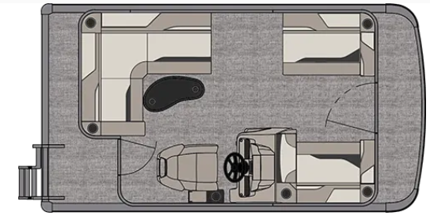
3713 State Route 31 Canastota, NY 13032
(315) 697-4867 Fax (315) 697-4868
www.oneidalakemarina.com
email: oneidalakemarina@gmail.com



2025 15’ Tahoe Sport Cruise
(8’ Wide – 15’ LOA) – ( $19,800.00)
w/Mercury 20hp EFI 4-Stroke
($4,275.00)
Black Walls, Buckskin & Cream White Interior w/Black Accents,
& Black Canvas

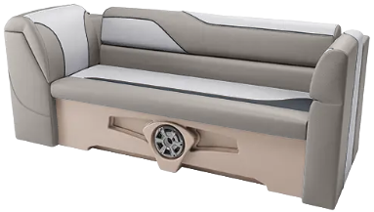
OPTIONS INCLUDED IN THIS PRICE:

Starboard Sport Low Back w/Arms
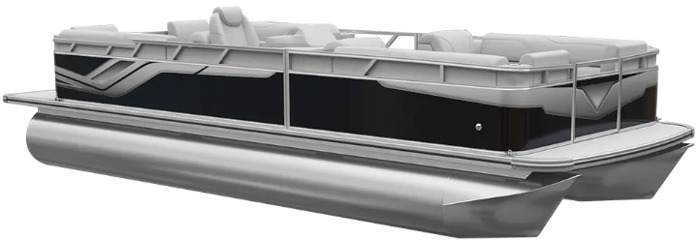
Erie Steering Wheel
Mechanical Tilt Steering
Riptide Shadow Flooring
25 Inch Tubes
15 Gallon Direct Fill Fuel Tank
Individual Seat Covers
90 Degree Smoked Chrome Docklights
WAS $27,075.00
OLM Left-Over Blow-out Price!
$24,075.00+ Tax & Registration
MSRP: $36,423.44

PRICE INCLUDES: Free Local Delivery, Complete Coast Guard Kit, Freight/Prep, & Full Tank of Fuel

Optional Trailer Pricing:
Load Rite P162200NT 2200T $3,600.00
(Single Axle, No Brake, 2200lb. Capacity)

Boat: DVN66352G425
Motor: 0R

