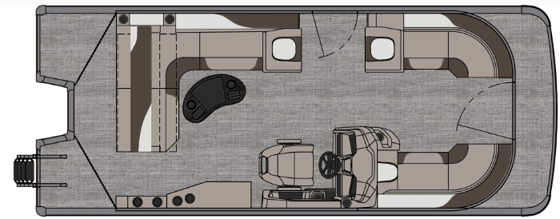
Oneida Lake Marina OLM #25-17
3713 State Route 31 Canastota, NY 13032
(315) 697-4867 Fax (315) 697-4868
www.oneidalakemarina.com
email: oneidalakemarina@gmail.com



2025 21’ Tahoe LTZ Cruise Rear Bench
(8 ½’ Wide – 21’ LOA) – ( $35,225.00)
w/Honda 100hp EFI 4-Stroke
($10,550.00)
Steel Blue & White Flake Metallic Walls, Buckskin & Cream White Interior w/Navy Accents,
& Black Canvas
OPTIONS INCLUDED IN THIS PRICE:
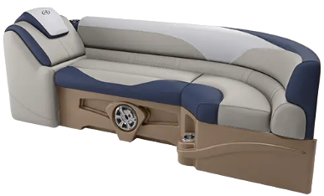
Starboard Sport High Back Reclining Chair
Blue Ice Light Package
Lights Under Rub Rail
Electric Bimini
Stainless Cladding Inserts
Ontario Steering Wheel
Baystar Tilt Steering
Garmin 52CV US
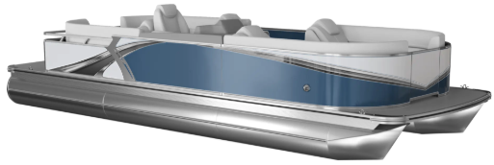
Riptide Shadow Flooring
25 Inch Tubes
25 Gallon Direct Fill Fuel Tank
Privacy Station Rail and Curtain
Individual Seat Covers
Polished Corner Caps
Smoked Chrome Docklight Assy
Lillipad Easy Step Ladder
Outboard Ski Tow Bar w/Chained Aft
WAS $50,425.00
OLM Left-Over Blow-out Price!
$45,775.00+ Tax & Registration
MSRP: $63,443.75PRICE INCLUDES: Free Local Delivery, Complete Coast Guard Kit, Freight/Prep, & Full Tank of Fuel
Optional Trailer Pricing:
Load Rite P20/22 2750T $3,800.00
(Single Axle, No Brake, 2750lb. Capacity)

Boat: DVN66337G425
Motor: BBWJ-1003249

