Oneida Lake Marina OLML #26-10
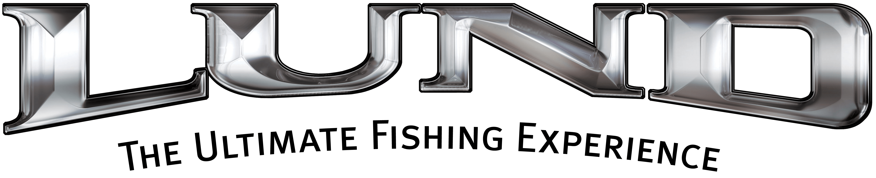
3713 State Route 31 Canastota, NY 13032
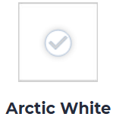
(315) 697-4867 Fax (315) 697-4868
www.oneidalakemarina.com
email: oneidalakemarina@gmail.com
315-697-4867
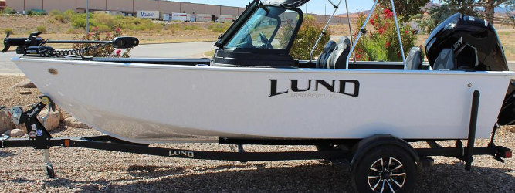

Catalog Picture
Trolling Motor & Fish Finder are Included

2026 LUND 1650 Rebel XL Sport SE
w/90hp Mercury EFI 4-Stroke
(LOA – 16’7”) (Beam – 7’)
Includes These Factory Installed Options:
• Special Edition All White Boat w/Black Raised Graphic
• Complete Vinyl Floor
• 1 Additional Proride Seat W/solid Ped
• Aft Flip-up Seat-complete Vinyl Boat
• Aluminum Prop
• Auto Bilge Pump Option
• Boarding Ladder w/Platform - Starboard
• Bunk Trailer Lunguard Black w/Load Guides & Spare
• Electronics Package-Level 1 Humminbird/Minn Kota (Humminbird Helix 5 Chirp GPS G3 console, Minn Kota
Powerdrive 55/DSC/FP-54", Minn Kota Precision Digital 2 Bank On Board Charger-Charger and Trolling Motor Mount Installed)
• Fire Extinguisher
• Kicker Kmc1 Stereo With 2 Speakers
• Tilt Steering Upgrade w/Seat Slider
• Travel Cover
OLM PRICE
$37,250.00+ Tax & Registration
MSRP: $47,237.00

Boat – 2026 Z16XDS – LBBRD099K526
Motor – 2026 90ELPT - 3B686285
Trailer – 2026 ShoreLand’r B22L - 1MDAHAR15TA810434

