Oneida Lake Marina OLM #26-30
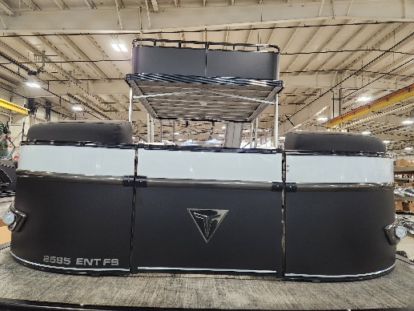
3713 State Route 31 Canastota, NY 13032

(315) 697-4867 Fax (315) 697-4868
www.oneidalakemarina.com
email: oneidalakemarina@gmail.com

2026 25’ Tahoe Cascade ENT FunShip Tri-toon
(8 ½’ Wide - 25’ Deck) – ( $82,800.00)
w/Honda BF250DXDA WT (iST) EFI 4-Stroke
($24,200.00)
Black Matte & White Flake Metallic Walls, Graphite & Bright White Interior, w/Black Accents, & Black Canvas
ADDED OPTIONS INCLUDED IN THIS PRICE:
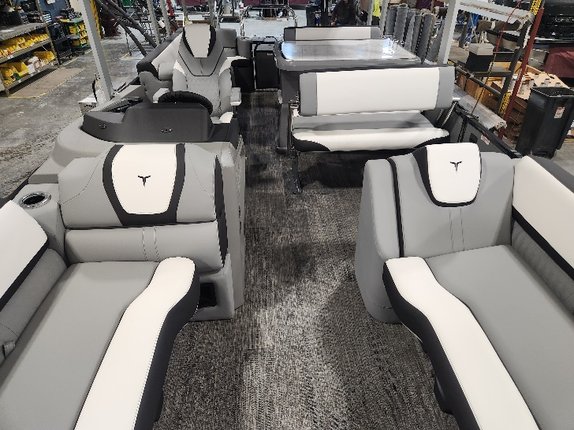
Starboard Admiral High Back Reclining Chair
27” Waveglider Tri-toon Package
Ultra Fine Vinyl Upgrade
RGB Light Package
Charcoal Seat Cladding w/SS Inserts
Garmin 72SV US GPS
Driftwood Flooring
Blackout Package
Lillipad Easy Step Ladder
DECO Docklights
Upper and Lower Deck Full Mooring Cover
Uflex Masterdrive Power Assist Steering & Michigan Steering Wheel
Booth Seating & Drawer Unit w/Glovebox and Dog Bowl Insert in Privacy Arm
High Performance Sound Package (Fusion RA-670 Radio, 8 Fusion XS Lit Speakers With Grills, Fusion 6-Channel Amp
Fusion 10 inch Subwoofer, USB Audio Input, and Charger)
ONEIDA LAKE MARINA SALE PRICE
$107,000.00+ Tax & Reg
MSRP: $141,565.00
PRICE INCLUDES: Free Local Delivery, Complete Coast Guard Kit, Freight/Prep, & Full Tank of Fuel

Optional Trailer Pricing:
Load Rite P24/26T 6000TriB1 $7,825.00
(Galvanized, Dual Axle, Dual Brake, 6000lb. Capacity)

Boat – DVN73691G526
Motor – BBNJ-

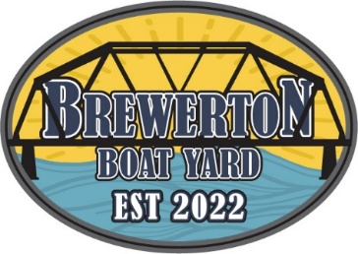

OLM #26-30

2026 25’ Tahoe Cascade ENT FunShip Tri-toon
(8 ½’ Wide - 25’ Deck) – ( $82,800.00)
w/Honda BF250DXDA WT (iST) EFI 4-Stroke
($24,200.00)
Black Matte & White Flake Metallic Walls, Graphite & Bright White Interior, w/Black Accents, & Black Canvas
ADDED OPTIONS INCLUDED IN THIS PRICE:
Starboard Admiral High Back Reclining Chair
27” Waveglider Tri-toon Package
Ultra Fine Vinyl Upgrade
RGB Light Package
Charcoal Seat Cladding w/SS Inserts
Garmin 72SV US GPS
Driftwood Flooring
Blackout Package
Lillipad Easy Step Ladder
DECO Docklights
Upper and Lower Deck Full Mooring Cover
Uflex Masterdrive Power Assist Steering & Michigan Steering Wheel
Booth Seating & Drawer Unit w/Glovebox and Dog Bowl Insert in Privacy Arm
High Performance Sound Package (Fusion RA-670 Radio, 8 Fusion XS Lit Speakers With Grills, Fusion 6-Channel Amp
Fusion 10 inch Subwoofer, USB Audio Input, and Charger)
ONEIDA LAKE MARINA SALE PRICE
$107,000.00+ Tax & Reg
MSRP: $141,565.00
PRICE INCLUDES: Free Local Delivery, Complete Coast Guard Kit, Freight/Prep, & Full Tank of Fuel

Optional Trailer Pricing:
Load Rite P24/26T 6000TriB1 $7,825.00
(Galvanized, Dual Axle, Dual Brake, 6000lb. Capacity)

Boat – DVN73691G526
Motor – BBNJ-

