Oneida Lake Marina OLM #26-3
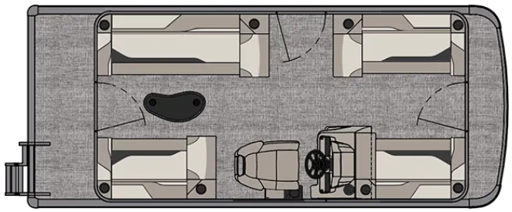
3713 State Route 31 Canastota, NY 13032

(315) 697-4867 Fax (315) 697-4868
www.oneidalakemarina.com
email: oneidalakemarina@gmail.com

2026 19’ Tahoe Sport Quad Lounge
(8’ Wide - 19’ Deck) – ( $26,518.00)
w/Honda BF90 EFI 4-Stroke
($10,200.00)
Sage Metallic Walls, Graphite & Silver Interior, w/Sage Accents, & Black Canvas

ADDED OPTIONS INCLUDED IN THIS PRICE:

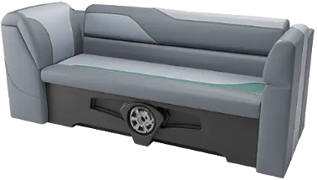

Starboard Sport Low Back Chair w/Arms
Charcoal Seat Cladding
25 Inch Pontoons
8’ Width Upgrade
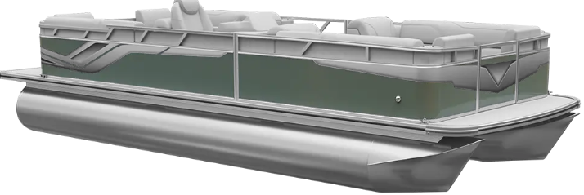
Uflex Mechanical Tilt Steering
Riptide Shadow Flooring
Privacy Station Rail and Curtain
Individual Seat Covers
25 Gallon Direct Fill Fuel Tank

ONEIDA LAKE MARINA SALE PRICE
$36,718.00+ Tax & Reg
MSRP: $44,362.50

PRICE INCLUDES: Free Local Delivery, Complete Coast Guard Kit, Freight/Prep, & Full Tank of Fuel

Optional Trailer Pricing:
Load Rite P18/20 2750T $3,720.00
(Galvanized, Single Axle, No Brake, 2750lb. Capacity)

Boat – DVN73506G526
Motor – BBCJ-1421534

