Oneida Lake Marina OLM #26-5
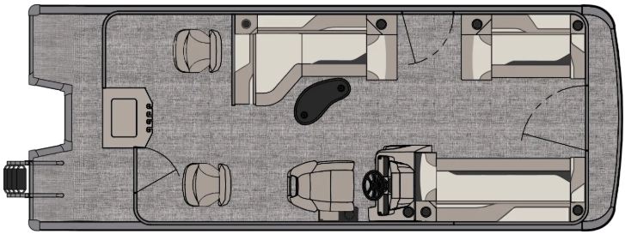
3713 State Route 31 Canastota, NY 13032

(315) 697-4867 Fax (315) 697-4868
www.oneidalakemarina.com
email: oneidalakemarina@gmail.com

2026 21’ Tahoe Sport Rear Fish
(8’ Wide - 21’ Deck) – ( $27,874.00)
w/Honda BF100 EFI 4-Stroke
($10,550.00)
Black Matte Walls, Buckskin & Cream White Interior, w/Black Accents, & Black Canvas

ADDED OPTIONS INCLUDED IN THIS PRICE:

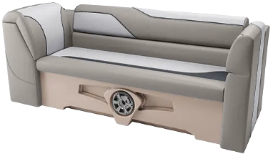

Starboard Sport Low Back Chair w/Arms
Buckskin Seat Cladding
25 Inch Pontoons
90 Degree Smoke Chrome Docklights
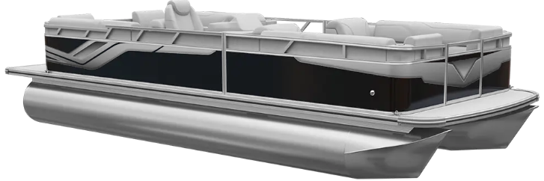
Uflex Mechanical Tilt Steering
Riptide Shadow Flooring
Privacy Station Rail and Curtain
Individual Seat Covers
Garmin 52CV US

ONEIDA LAKE MARINA SALE PRICE
$38,424.00+ Tax & Reg
MSRP: $46,784.38

PRICE INCLUDES: Free Local Delivery, Complete Coast Guard Kit, Freight/Prep, & Full Tank of Fuel

Optional Trailer Pricing:
Load Rite P20/22 2750T $3,800.00
(Galvanized, Single Axle, No Brake, 2750lb. Capacity)

Boat – DVN73509G526
Motor – BBMJ-1125337

