Oneida Lake Marina OLML #26-7
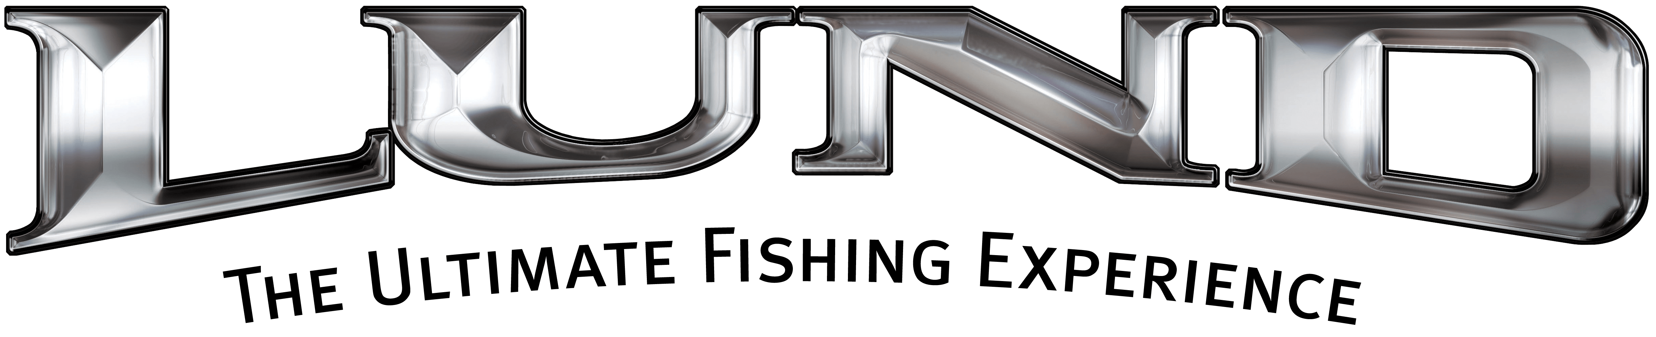
3713 State Route 31 Canastota, NY 13032
(315) 697-4867 Fax (315) 697-4868
www.oneidalakemarina.com

email: oneidalakemarina@gmail.com
315-697-4867

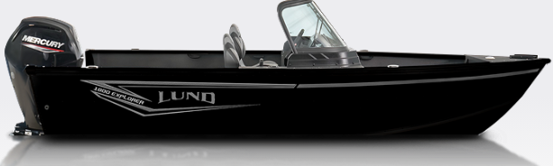

Catalog Picture
2026 LUND 1800 Explorer Sport
w/115hp Mercury ProXS EFI 4-Stroke
(LOA – 18’) (Beam – 7’9”)
Includes These Factory Installed Options:
• All Black Boat
• Complete Vinyl Floor
• Aluminum Prop
• Auto Bilge Pump Option
• Bunk Trailer Lunguard Black
• Center Rod Locker
• Fire Extinguisher
• Kicker Kmc1 Stereo w/2 Speakers
• Ladder Mounted on Starboard Side-standard
• Rod Tube Option - Port
• Travel Cover

$42,750.00+ Tax & Registration
MSRP: $55,636.00

Boat – 2026 Z18ED – LBBXF126K526
Motor – 2026 115ELPT ProXS - 3B736267
Trailer – 2026 ShoreLand’r LUB22SELWSS8 -
1MDAPAT10TA810451

