Oneida Lake Marina OLML #26-9
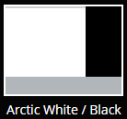
3713 State Route 31 Canastota, NY 13032
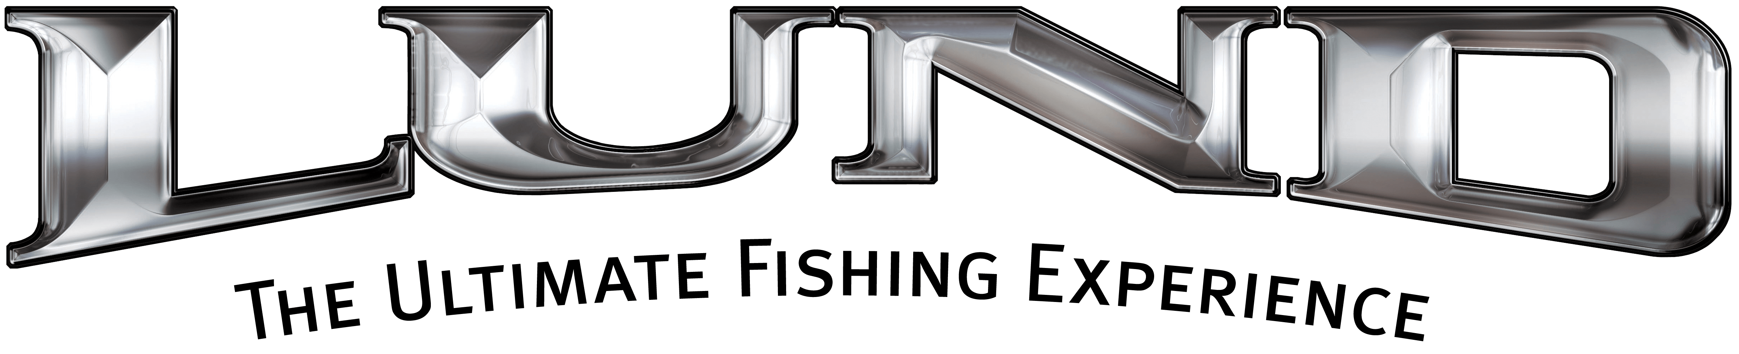
(315) 697-4867 Fax (315) 697-4868
www.oneidalakemarina.com
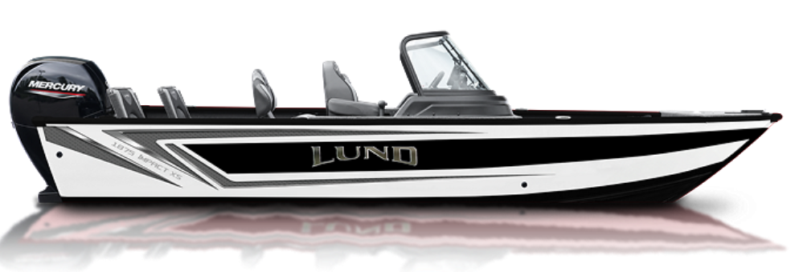
email: oneidalakemarina@gmail.com
315-697-4867

Trolling Motor & Fish Finder are Included
Catalog Picture
2026 LUND 1875 IMPACT XS
w/150hp Mercury ProXS EFI 4-Stroke
(LOA – 18’11”) (Beam – 8’)
Includes These Factory Installed Options:
• Complete Vinyl Floor & 1 Additional Proride Seat w/Airride Ped
• Premium Edition Graphics
• 4 Bank Minnkota Onboard Charger (Set Up to Charge THREE Trolling Motor Batteries and One Starting Battery)
• Airride Pedestal Upgrade
• Bow Cushion W/integrated Back Rest Set
• Bunk Trailer Lunguard Black
• Phone Charger-wireless & House Battery Option
• Top Hider & Fire Extinguisher
• Humminbird Xplore 9 Cmsi+ Console Mount
• Hydraulic Steering W/tilt Helm
• Impact XLT Package (Drivers Air Ride Pedestal/slider, Chrome Lund Logo, Ski Pylon, Travel cover)
• Minnkota-terrova 80/mdi/wr-60"
• Rockford Stereo Upgrade w/4 Rockford Speakers
• Under Console Drawer Port & Starboard & Stainless Prop

$72,000.00+ Tax & Registration
MSRP: $82,881.00

Boat – 2026 Z18IX – LBBKJ843K526
Motor – 2026 150XL ProXS - 3B729324
Trailer – 2026 ShoreLand’r LUV30BELWSS8 -
1MDAJAU17TA810723

