Oneida Lake Marina OLML #26-12

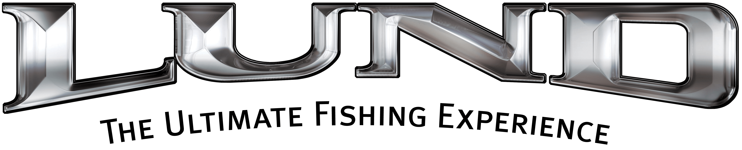
3713 State Route 31 Canastota, NY 13032
(315) 697-4867 Fax (315) 697-4868
www.oneidalakemarina.com
email: oneidalakemarina@gmail.com
315-697-4867
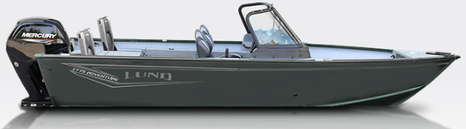

Catalog Picture
Trolling Motor & Fish Finder are Included
2026 LUND 1775 Adventure Sport
w/115hp Mercury ProXS EFI 4-Stroke
(LOA – 17’10”) (Beam – 7’3”)
Includes These Factory Installed Options:
• Complete Vinyl Floor w/Vinyl Freeboards
• 1 Additional Proride Seat w/Solid Pedestal
• Adventure XLT Package (Kicker Stereo w/2 Speakers, Driver Seat Slider, Ski Tow- Base Only No Pylon Included, & Travel Cover)
• Aluminum Prop
• Auto Bilge Pump Option
• Bunk Trailer Lunguard Black w/Spare & Load Guides
• Electronics Package-Level 2 Humminbird/Minn Kota (Humminbird Helix 7 Chirp MDI GPS G4N, Minn Kota Terrova
80/MDI/WR-60", Minn Kota Precision Digital Charger 3 Bank On Board Charger-Charger and Trolling Motor Mount Installed)
• Phone Charger-wireles
• Fire Extinguisher
• Graphics Upgrade
• Sport Top w/Walkway Curtain
• On The Go Rod Storage - Port Side
OLM PRICE

$48,500.00+ Tax & Registration
MSRP: $60,791.00

