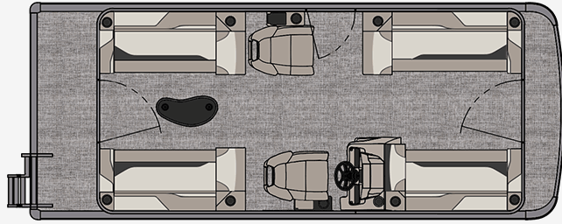
Oneida Lake Marina OLM #1
3713 State Route 31 Canastota, NY 13032
(315) 697-4867 Fax (315) 697-4868
www.oneidalakemarina.com
email: oneidalakemarina@gmail.com

2024 21’ Tahoe Sport Quad Lounge
(8’ Wide - 21’ 5” LOA) – ( $26,524.00)
w/Honda BF100hp EFI 4-Stroke
($10,550.00)
Steel Blue Walls, Buckskin & Cream White Interior, w/Indigo Accents,
& Blue Canvas

ADDED OPTIONS INCLUDED IN THIS PRICE:
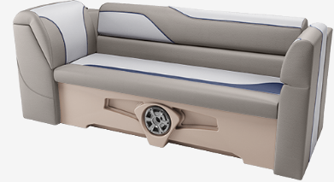

Starboard Sport Low Back w/Arms
Ontario Steering Wheel
Mechanical Tilt Steering
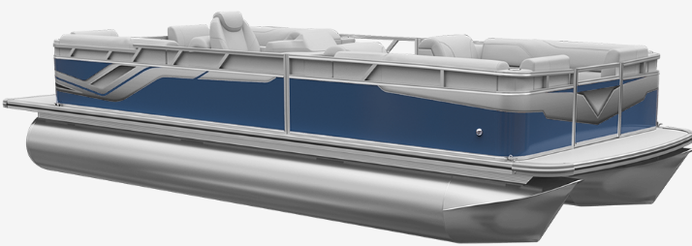
Riptide Shadow Flooring
25 Inch Tubes
Outboard Ski Tow Bar
Privacy Station Rail and Curtain
Individual Seat Covers

ONEIDA LAKE MARINA SALE PRICE

$37,074.00+ Tax & Reg
MSRP: $44,284.38
PRICE INCLUDES: Free Local Delivery, Complete Coast Guard Kit, Freight/Prep, & Full Tank of Fuel

Optional Trailer Pricing:
Load Rite P20/22 2750T $3,575.00
(Single Axle, No Brake, 2750lb. Capacity)

Boat - DVN60561H324
Motor - BBMJ-1123735

