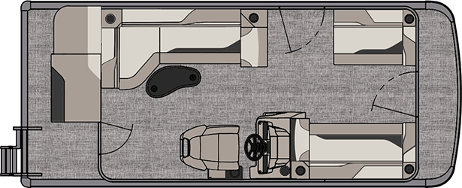
Oneida Lake Marina OLM #2
3713 State Route 31 Canastota, NY 13032
(315) 697-4867 Fax (315) 697-4868
www.oneidalakemarina.com
email: oneidalakemarina@gmail.com

2024 19’ Tahoe Sport Cruise
(8’ Wide - 19’ 5” LOA) – ( $25,300.00)
w/Yamaha F90hp EFI 4-Stroke
($10,825.00)
Black Walls, Buckskin & Cream White Interior, w/Black Accents,
& Black Canvas

ADDED OPTIONS INCLUDED IN THIS PRICE:
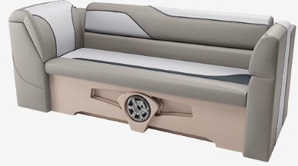

Starboard Sport Low Back w/Arms
Ontario Steering Wheel
Mechanical Tilt Steering
Riptide Shadow Flooring
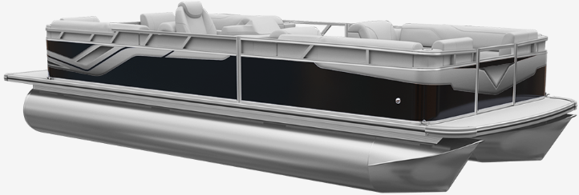
25 Inch Tubes
25 Gallon Direct Fill Fuel Tank
Privacy Station Rail and Curtain
Individual Seat Covers

ONEIDA LAKE MARINA SALE PRICE

$36,125.00+ Tax & Reg
MSRP: $43,215.31
PRICE INCLUDES: Free Local Delivery, Complete Coast Guard Kit, Freight/Prep, & Full Tank of Fuel

Optional Trailer Pricing:
Load Rite P18/20 2750T $3,425.00
(Single Axle, No Brake, 2750lb. Capacity)

Boat - DVN60560H324
Motor - 6FPL-1041647

